|  |
| --- |
| Department of Computer & Software Engineering  **Bahria University Karachi Campus**  13 National Stadium Road |

|  |
| --- |
| Database Management System |
| Vehicle License Management System |
| |  |  | | --- | --- | | **Submitted To** | **Engr. Adnan ur Rehman / Engr. Mobeen Nazar** | | **Student(s)** |  | | Zaroon Farrukh | REG # 40971 | |

**Table of Contents**

01 Introduction: 2

02 Goal: 2

03 Existing solutions / Projects: 2

04 Proposed Solution: 4

05 Work Flow Diagram 5

06 ERD 6

07 Database Queries 6

07.1 Queries 6

08 GUI Specification 7

09 Conclusion 10

10 References 11

# Introduction:

Vehicle license management system is made keeping in view the large-scale audience and public appearing for license issuance. Since the existing system was all paper based which consumes more time in processing of every individual, the need for automation of this problem was now a necessity which is fulfilled through this License Management System.

# Goal:

The goal of the project is to save the time and provide ease of access to the candidates appearing for license. The user will have a computer based MCQ exam on successful completion of which he / she would be eligible for the license. And a learners license would be provided to them through a crystal report.

# Existing solutions / Projects:

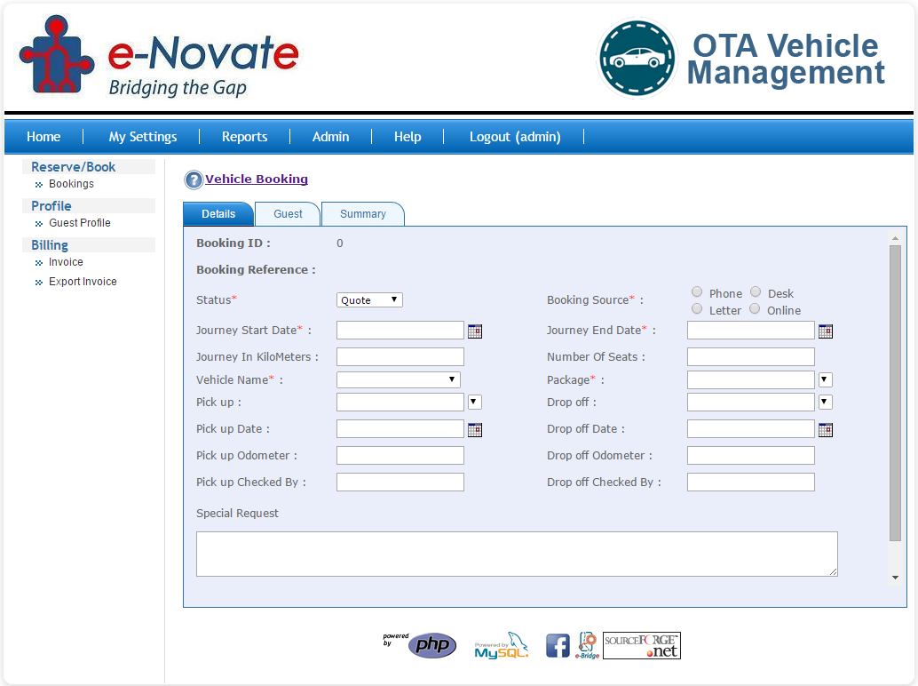

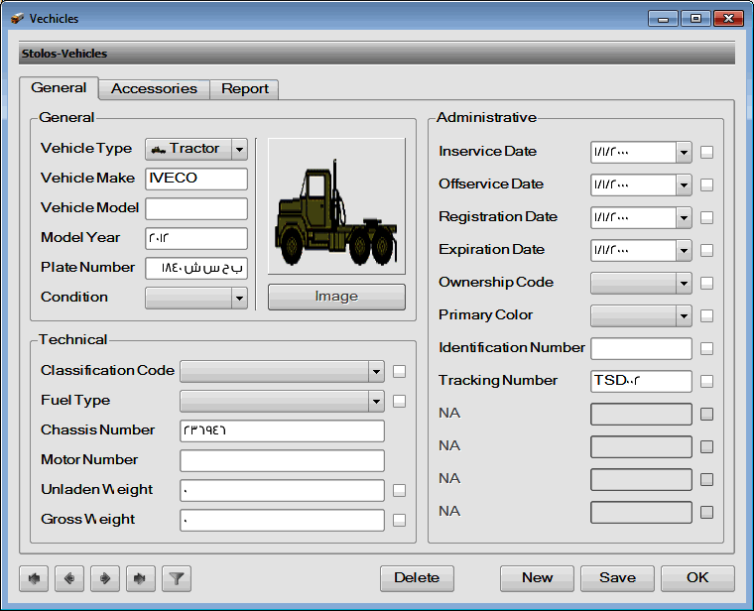

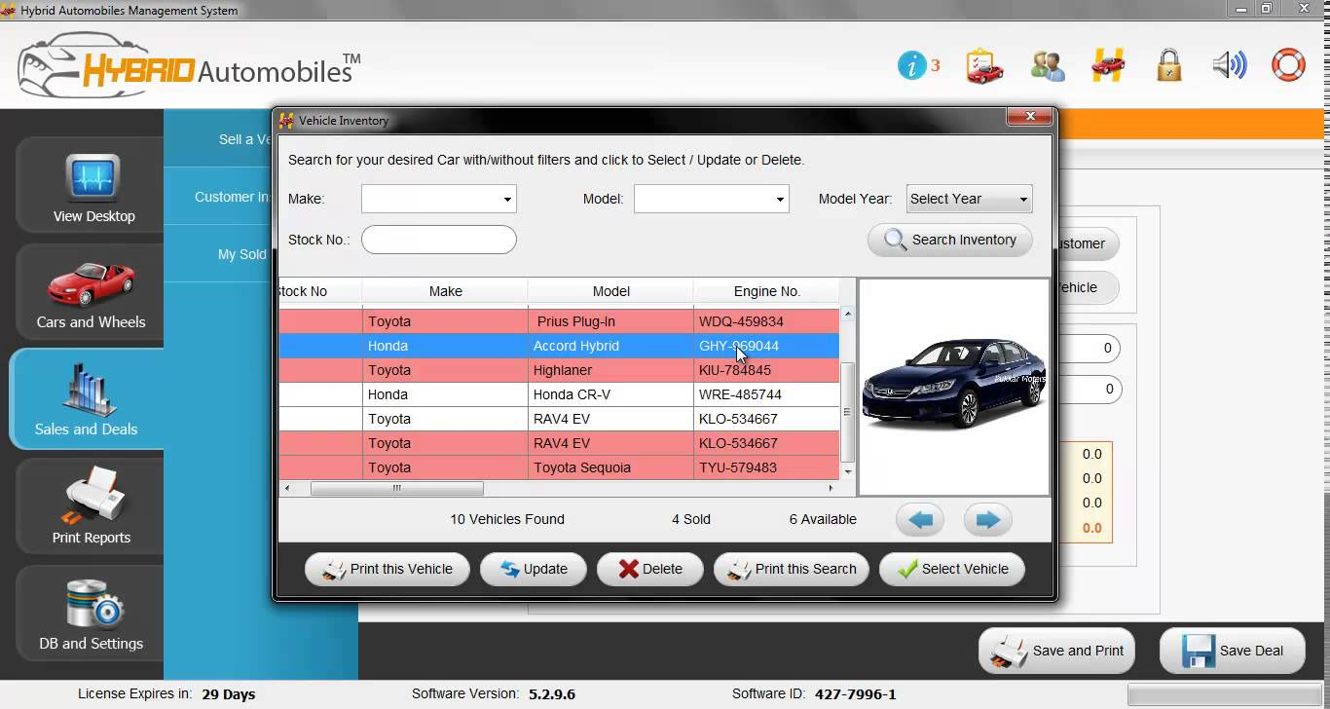

# Proposed Solution:

The proposed solution consists of MCQ exam as well which the above projects don’t have.

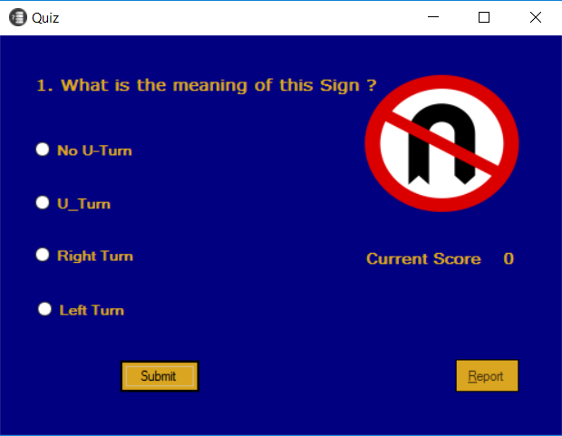

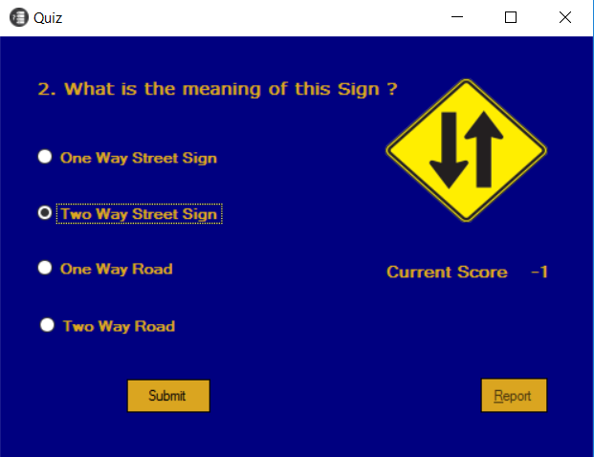

# Work Flow Diagram



Ask for a License

New Or Renew

New License

Enter Credentials

Renew License

Do you want to update

Yes

Updated

Generate Report

Quiz Passed

Take Quiz

Yes

Fail

# ERD

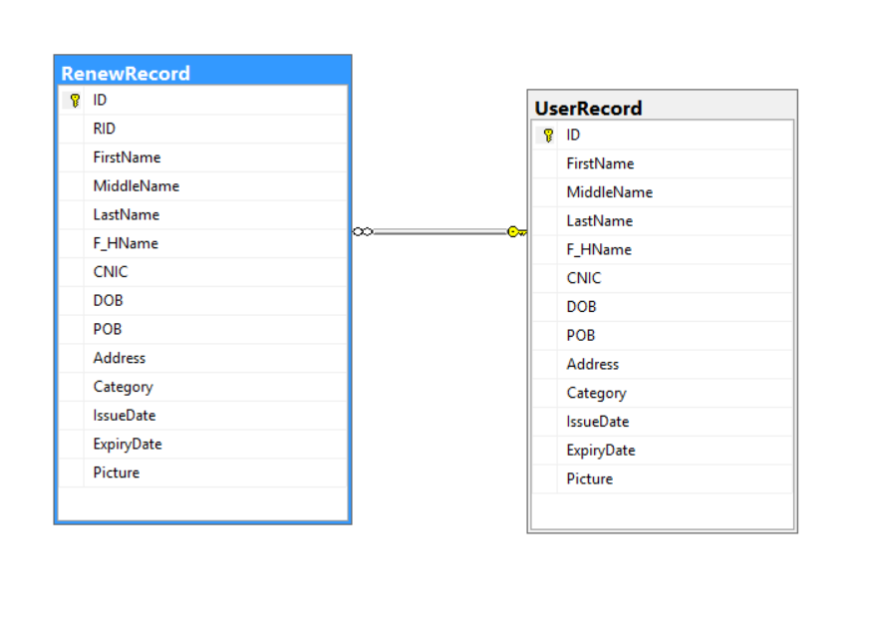

# Database Queries

## Queries

"Select count(*) as IsExists from " + tableName;

"Select Max(ID) from UserRecord", "UserRecord"

"Delete from RenewRecord where ID!='"+ID_Label.Text+"'"

"insert into UserRecord(ID,FirstName,MiddleName,LastName,F_HName,CNIC,DOB,POB,Address,Category,Picture,IssueDate,ExpiryDate) values ('"+ID_Label.Text+"','" + textBox1.Text + "','" + textBox2.Text + "','" + textBox3.Text + "','" + textBox4.Text + "','" + maskedTextBox1.Text + "','" + Convert.ToDateTime(dateTimePicker1.Value.ToShortDateString()) + "','" + textBox6.Text + "','" + textBox7.Text + "','" + comboBox1.Text + "',@picture,'" + DOI.Text + "','" + DOE.Text + "')", pic_Box

("insert into RenewRecord(ID,FirstName,MiddleName,LastName,F_HName,CNIC,DOB,POB,Address,Category,Picture,IssueDate,ExpiryDate) values ('" + ID_Label.Text + "','" + textBox1.Text + "','" + textBox2.Text + "','" + textBox3.Text + "','" + textBox4.Text + "','" + maskedTextBox1.Text + "','" + Convert.ToDateTime(dateTimePicker1.Value.ToShortDateString()) + "','" + textBox6.Text + "','" + textBox7.Text + "','" + comboBox1.Text + "',@picture,'" + DOI.Text + "','" + DOE.Text + "')", pic_Box

"select * from UserRecord where CNIC='" + comboBox1.Text + "'"

"Select count(*) as IsExists from " + tableName

"Select CNIC from UserRecord"

"update UserRecord set FirstName='" + this.txtFirstName.Text + "',MiddleName='" + this.txtMiddleName.Text + "',LastName='" + this.txtLastName.Text + "',F_HName='" + this.txtF_HName.Text + "',Address='" + this.txtAddress.Text + "' where FirstName='" + this.txtFirstName.Text + "'"

"select [ID],[FirstName],[MiddleName],[LastName],[F_HName],[CNIC],[DOB],[POB],[Address],[Category],[IssueDate],[ExpiryDate] from UserRecord"

"Select Picture from UserRecord where ID='" + ID + "'"

# GUI Specification

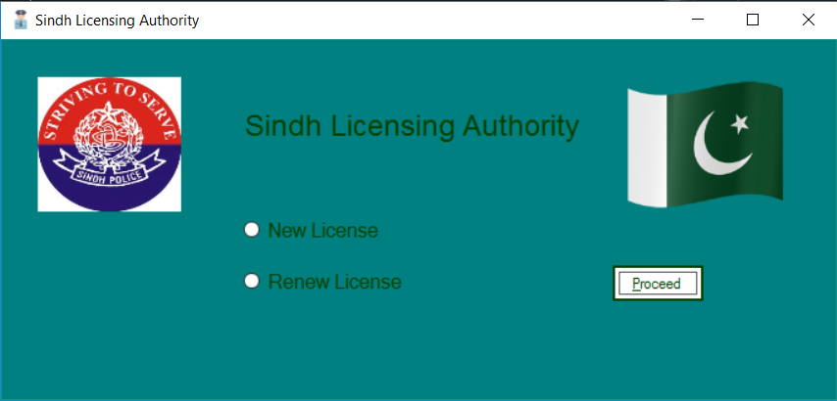

This is the Main form which allows the user to select either New License option or Renew License through the radiobutton.

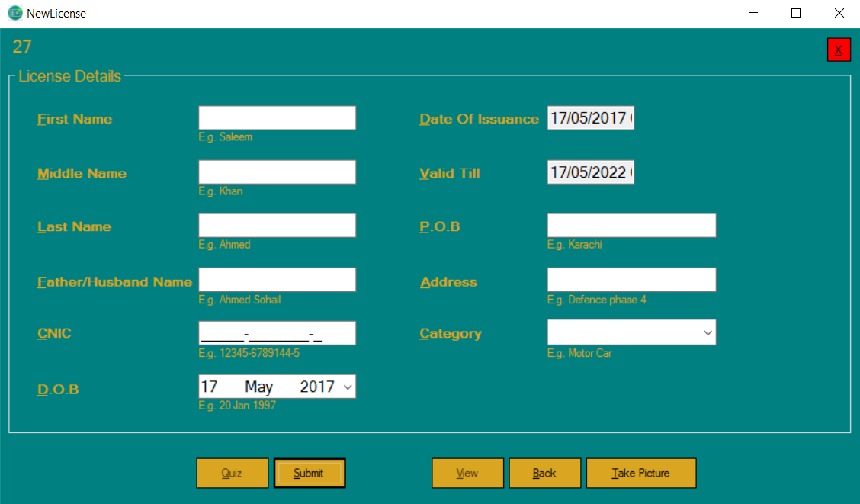

This is the New License form in which user will enter his / her credentials.



This form is the MCQ exam form which have several multiple choice questions.

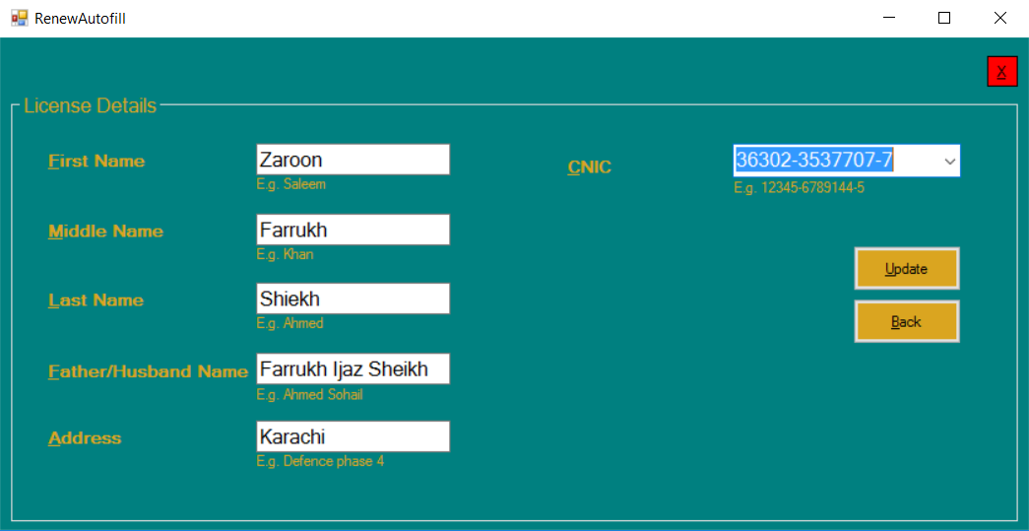

This is the Renew License form. The user have to select the CNIC and rest of textboxes are auto filled if the record exists.

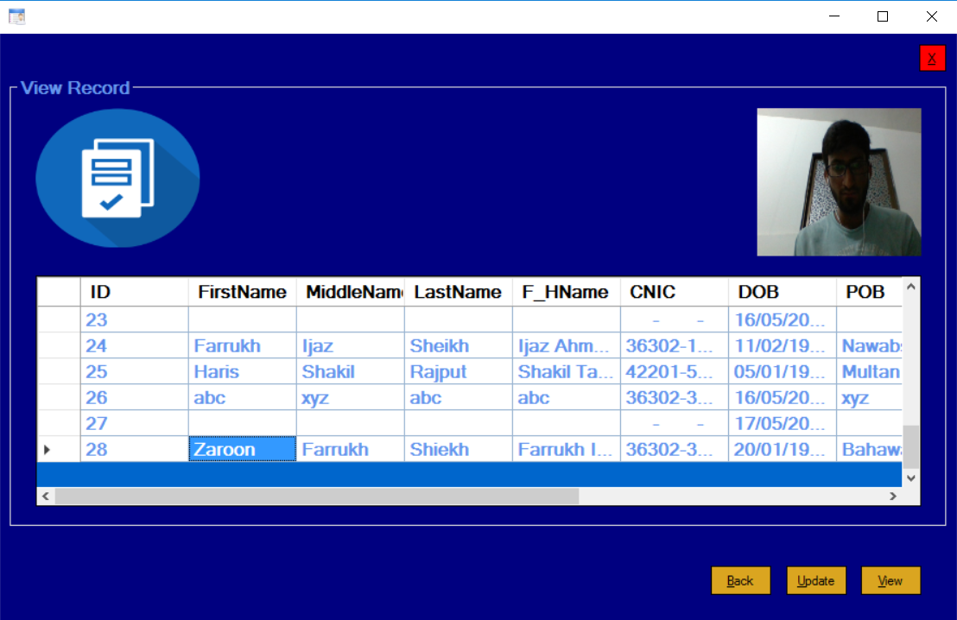

This is the View mode for the new license record entered by the user.

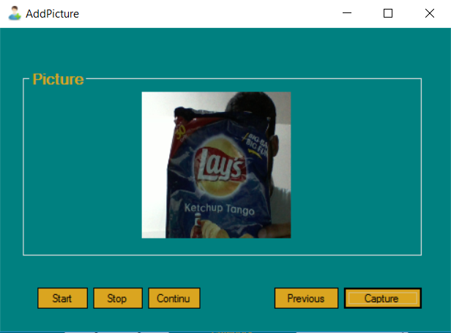

This form allows the user to capture the photo at runtime.

# Conclusion

The application concludes with a SAP Crystal Report. The Crystal Report is attached hereby.

# References

Stack Overflow

Code Project

C# Corner

Tutorials Point

Wikipedia